1) The inverting amplifier
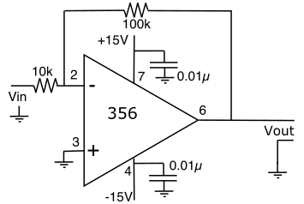
If we alter the non-inverting amplifier circuit of Lab 25 slightly, swapping the input signal and the ground connection to get the circuit shown to the right, then we have an inverting amplifier; an amplifier whose gain is negative.
NOTE : There is no standard for the inputs. You choose whether to draw the negative or positive input at the top to make the circuit look neat.

a) Use the formula in the book to predict the gain of this circuit and compare the gain to that of the previous circuit.
The gain of this circuit is -R2/R1 = -10. The gain of the previous circuit was 11. This makes sense, because this is an inverting amplifier, so we should expect a negative gain.

Build the circuit. Don’t forget to include the capacitors on the power supply lines. Connect up the oscilloscope and signal generator as before. Set the input to be a about 0.1V amplitude sine wave at 1kHz.
b) Paste an image showing the input and output on the same screen.
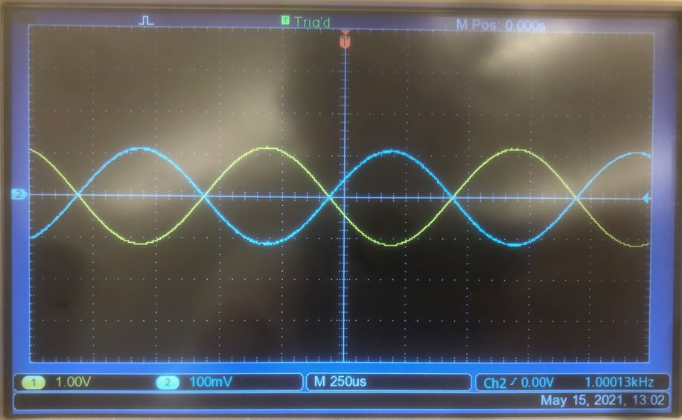

c) What is the actual gain of the circuit? How does this compare with the predicted gain
The gain of this circuit is -10. This matches the predicted gain exactly.

d) Use the op-amp Golden Rules to derive the gain expression that you used in part a.
Because the op-amp will optimize toward equalizing the voltages at its inputs, and the inputs draw no current, we know Vin/10k = -Vout/100k.
Thus, Vout = -10Vin.

One key difference between the previous circuit and this one is seen if you swap the two resistors.
e) What is the gain in this configuration?
The gain in this configuration is -1/10.

f) How does this compare with your work in Lab 25?
This is in line with lab 25. When we switched the resistors in lab 25, the gain dropped by a factor of 10. Here, it’s dropping by a factor of 100.

2) Op-Amp Bandwidth
Operational amplifiers are very nice but they are not perfect. The next few exercises explore some of the more important imperfections. The first limitation is the upper frequency limit of the circuit. An ideal amplifier would amplify all signals equally regardless of their frequency. Op-amps do not meet that ideal, though you can get remarkable results if you spend enough money.
I remind you again that, although power supplies and associated filter capacitors are rarely shown on the diagrams, they are ALWAYS required.
a) Swap the resistors back to give you the gain of 10 inverting amplifier and drive it from a small sine wave. You choose the amplitude but try to keep the output of the amplifier below 2V P-P.

Remember
dB = 20 log₁₀(Vout/Vin ₎

b) Make a Bode plot of the amplifier gain (log(Vout/Vin ) vs. log(frequency)) as you drive the input with sinewaves of frequencies from 10Hz to 1MHz. You should start by measuring the gain at 10 Hz, 100 Hz, 1 kHz, 100 kHz, and 1 MHz and then go back and fill in any regions that are interesting.
NOTE you don't need to bother with the phase this time.
c) Paste your Bode plot below.
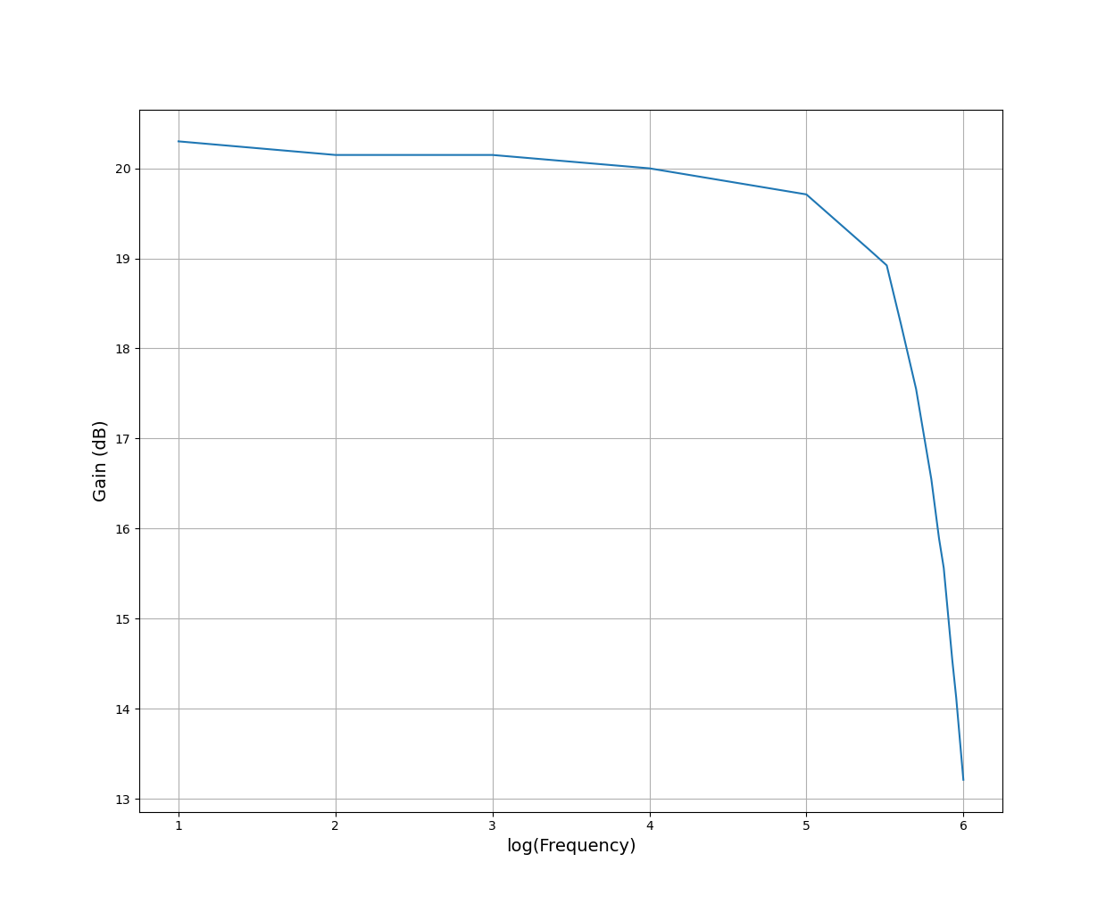

d) Explain, qualitatively, the shape of this graph.
As the frequency increases, the gain decreases slowly at first, then very quickly.

e) What is the cut-off frequency for this circuit?
(Just as for a low-pass filter, the cut-off is the frequency at which the gain falls to 70% of its maximum value, that is, the frequency at which the gain has fallen by 3dB).
The cut-off frequency is at 500kHz. At 500kHz, the gain is about 17.5 dB, which is 3 less than the ~20.5 initial gain.

Since the amplifier operates well at all frequencies from DC up to this maximum, we often call the maximum useable frequency the bandwidth of the amplifier.
f) What is the bandwidth of your amplifier?
The bandwidth of my amplifier is 500kHz.

3) The Gain-Bandwidth Product
The maximum useable frequency is strongly dependent on the gain. Indeed, the product of the gain and the maximum useable frequency, the gain-bandwidth product (GBW), is approximately constant for a given choice of op-amp. A wide variety of op-amps are available with gain-bandwidths ranging from a few kHz to more than 1 GHz.
a) Compute the gain-bandwidth product of the 356 in this circuit.
The gain-bandwidth product is 500kHz * 10 = 5MHz.

b) Now change the feedback resistors to make an amplifier with a gain of 100 and re-measure the cut-off frequency. NOTE: In order to avoid a secondary bandwidth effect you must also reduce the input signal to keep the output signal about the same size as it was with the x10 amplifier. You want to keep the output voltage under 2V p-p.
I solved for the P-P voltage at the cutoff frequency, then binary searched my way down to find that 55kHz is the cutoff frequency.

c) Compute a new gain-bandwidth product and compare it to the previous value. Does your result support the idea that the gain-bandwidth product is reasonably constant?
Thus, the gain-bandwidth product is 5.5MHz. This is pretty close to the value I got earlier.

d) Compare your measured gain-bandwidth with the value from the LF356 datasheet.
The datasheet says the gain-bandwidth product is 5MHz, so I was right at first.

4) Slew-Rate Limit
In addition to the simple low-pass filter behavior that we explored in the last lab, op-amps suffer from a second frequency limitation. There is a limit to the maximum rate at which the output can change or slew. This becomes important as we try to amplify larger signals (you have to get the output to slew through a larger voltage in the same time) or try to work with signals with sharper edges, such as square waves.

Effect on Bandwidth
Adjust your signal generator so that it produces sine waves with an amplitude of 1V (ie. 2V pk-pk) and repeat your Bode plot measurement.
a) What is the bandwidth for these high-amplitude signals (called the large-signal bandwidth)?
The bandwidth is 1.2MHz. I solved for this by computing the gain at 10Hz, then subtracting 3, and solving for Vout. The frequency that creates the correct P-P voltage is 550kHz.

b) Compare the large-signal bandwidth with the small-signal bandwidth that you measured above.
These values are very similar.

Effect on Shape
c) Pick a frequency that is above the large-signal bandwidth. Paste an image of the output of the large signal circuit and comment on its shape.
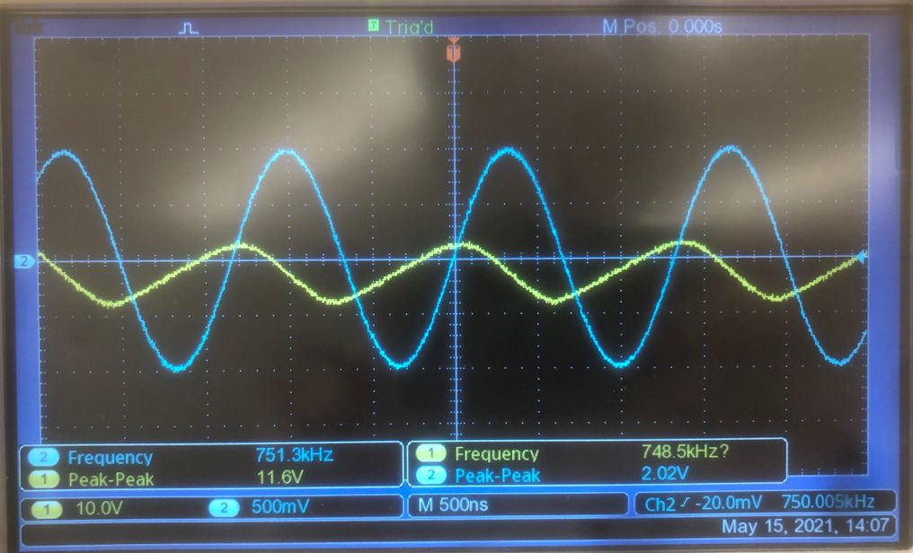

d) Explain (that means account for) the deviations from a sine wave.
The slew rate limit of the op-amp is too low for the slope of the output wave to align with that of the input wave. Thus, we see distortion.

e) The more we demand of the amplifier the closer to its limits it will come. Alter your signal generator to produce square waves at a frequency near the large-signal bandwidth. Draw the input and output of your circuit and measure the slew rate for both the rising and the falling waves as accurately as you can and comment on what you find.
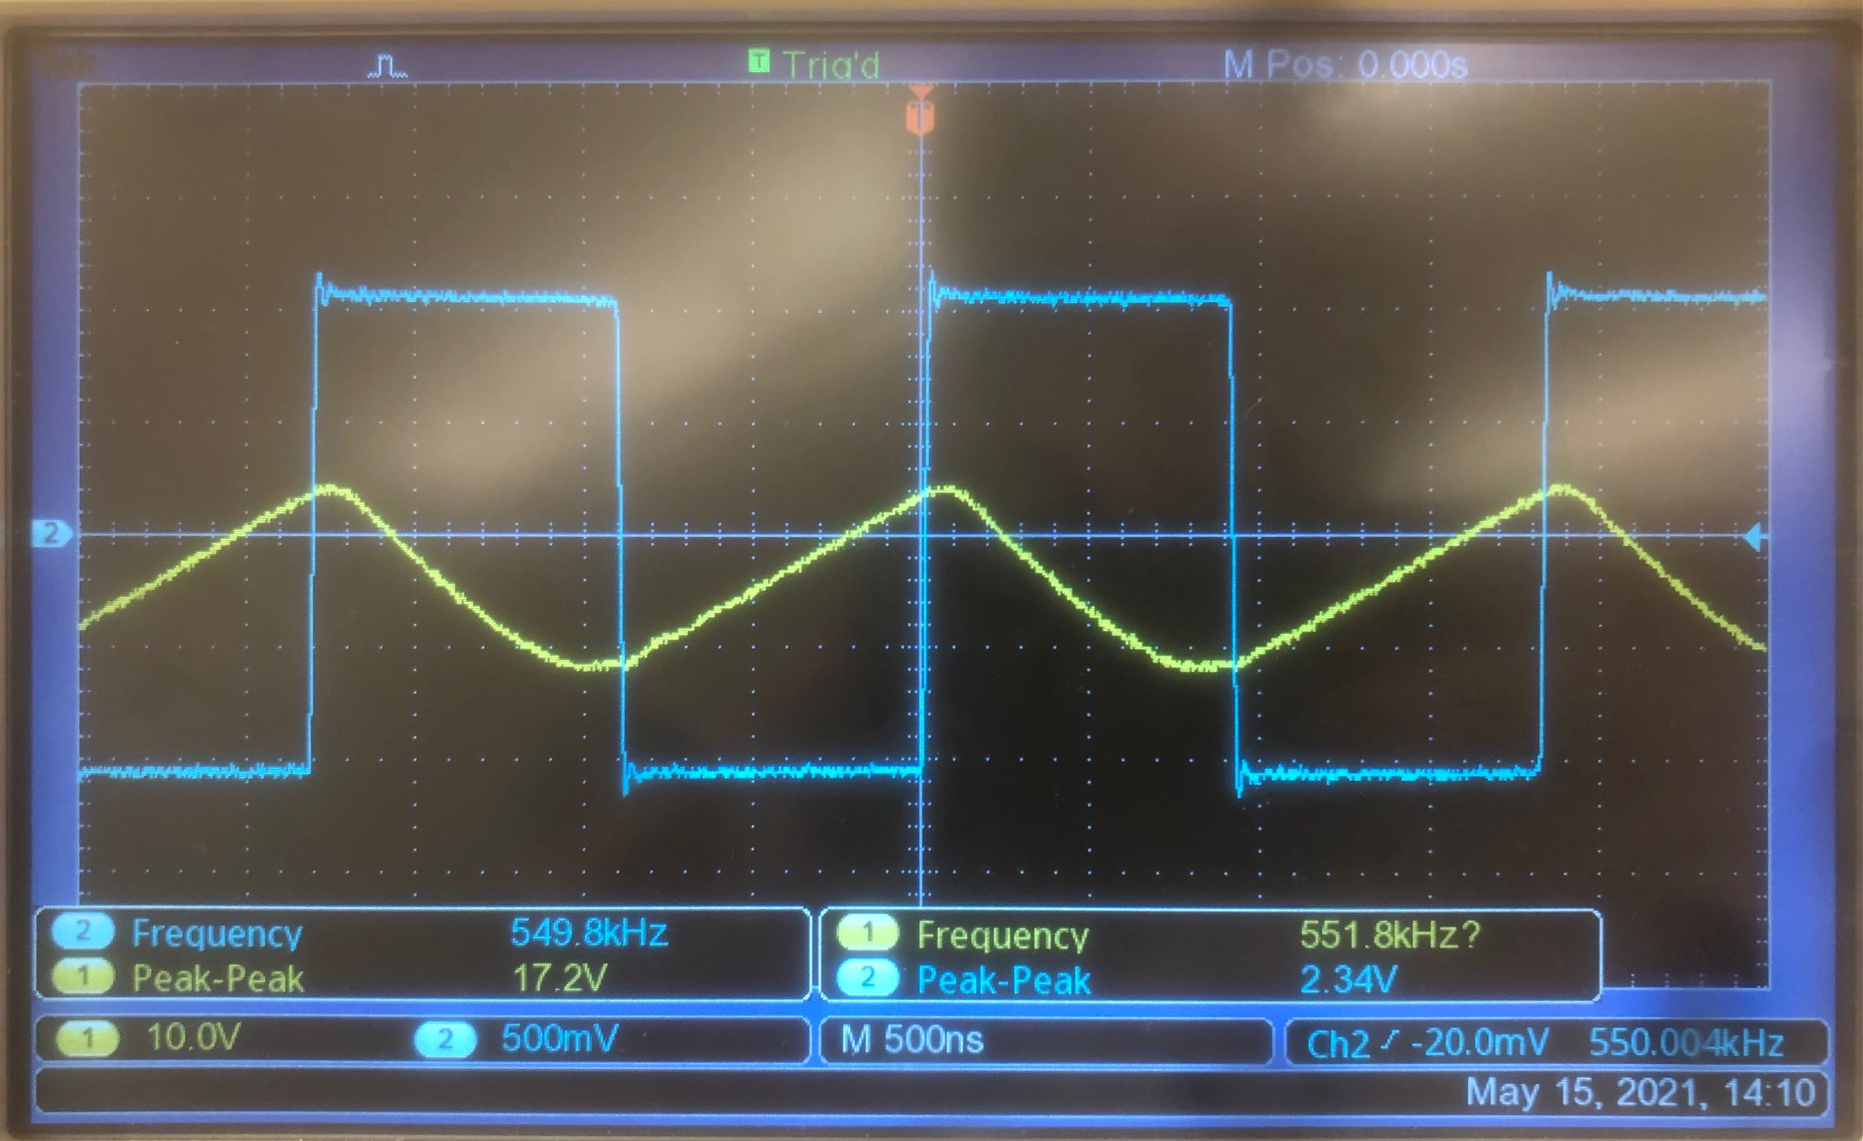
Rising slew rate limit: 0.0173 V / ns.
Falling slew rate limit: -0.024 V / ns.

f) Is the bandwidth of the LF356 for 20 Vp-p output sinewaves limited by the gain-bandwidth product or by the slew rate? (You must provide a detailed justification for your answer, possibly including images of waveshape).
The bandwidth is limited by the slew rate, because we can observe the output wave losing its sinewave shape as the frequency increases, indicating that the slope of the output wave would have to exceed the slew rate limit in order for the output wave to be a sinewave.

